**Details required for processing the payment (January, 23– February, 23)**

1. **Details of Project Start**

|  |  |  |
| --- | --- | --- |
| State | MoU date | Team placement date |
| Gujarat | 15/09/2Feb0 | 07/10/2Feb0 |

1. **Attendance of Team**

|  |  |  |  |  |  |  |
| --- | --- | --- | --- | --- | --- | --- |
| **S.no.** | **Date** |  | **PMU Manager** | **Attendance** | **Business Analyst** | **Attendance** |
|  | 02-Jan-23 | Monday | Neeraj Sharma | P | Sambit Mishra | P |
|  | 03-Jan-23 | Tuesday | Neeraj Sharma | P | Sambit Mishra | P |
|  | 04-Jan-23 | Wednesday | Neeraj Sharma | P | Sambit Mishra | P |
|  | 05-Jan-23 | Thursday | Neeraj Sharma | P | Sambit Mishra | P |
|  | 06-Jan-23 | Friday | Neeraj Sharma | P | Sambit Mishra | P |
|  | 09-Jan-23 | Monday | Neeraj Sharma | P | Sambit Mishra | P |
|  | 10-Jan-23 | Tuesday | Neeraj Sharma | P | Sambit Mishra | P |
|  | 11-Jan-23 | Wednesday | Neeraj Sharma | P | Sambit Mishra | P |
|  | 12-Jan-23 | Thursday | Neeraj Sharma | P | Sambit Mishra | P |
|  | 13-Jan-23 | Friday | Neeraj Sharma | P | Sambit Mishra | P |
|  | 16-Jan-23 | Monday | Neeraj Sharma | P | Sambit Mishra | P |
|  | 17-Jan-23 | Tuesday | Neeraj Sharma | P | Sambit Mishra | P |
|  | 18-Jan-23 | Wednesday | Neeraj Sharma | P | Sambit Mishra | P |
|  | 19-Jan-23 | Thursday | Neeraj Sharma | P | Sambit Mishra | P |
|  | 20-Jan-23 | Friday | Neeraj Sharma | P | Sambit Mishra | P |
|  | 23-Jan-23 | Monday | Neeraj Sharma | P | Sambit Mishra | P |
|  | 24-Jan-23 | Tuesday | Neeraj Sharma | P | Sambit Mishra | P |
|  | 25-Jan-23 | Wednesday | Neeraj Sharma | P | Sambit Mishra | P |
|  | 27-Jan-23 | Friday | Neeraj Sharma | P | Sambit Mishra | P |
|  | 30-Jan-23 | Monday | Neeraj Sharma | P | Sambit Mishra | P |
|  | 31-Jan-23 | Tuesday | Neeraj Sharma | P | Sambit Mishra | P |
|  | 01-Feb-23 | Wednesday | Neeraj Sharma | P | Sambit Mishra | P |
|  | 02-Feb-23 | Thursday | Neeraj Sharma | P | Sambit Mishra | P |
|  | 03-Feb-23 | Friday | Neeraj Sharma | P | Sambit Mishra | P |
|  | 06-Feb-23 | Monday | Neeraj Sharma | P | Sambit Mishra | P |
|  | 07-Feb-23 | Tuesday | Neeraj Sharma | P | Sambit Mishra | P |
|  | 08-Feb-23 | Wednesday | Neeraj Sharma | P | Sambit Mishra | P |
|  | 09-Feb-23 | Thursday | Neeraj Sharma | P | Sambit Mishra | P |
|  | 10-Feb-23 | Friday | Neeraj Sharma | P | Sambit Mishra | P |
|  | 13-Feb-23 | Monday | Neeraj Sharma | P | Sambit Mishra | P |
|  | 14-Feb-23 | Tuesday | Neeraj Sharma | P | Sambit Mishra | P |
|  | 15-Feb-23 | Wednesday | Neeraj Sharma | P | Sambit Mishra | P |
|  | 16-Feb-23 | Thursday | Neeraj Sharma | P | Sambit Mishra | P |
|  | 17-Feb-23 | Friday | Neeraj Sharma | P | Sambit Mishra | P |
|  | 20-Feb-23 | Monday | Neeraj Sharma | P | Sambit Mishra | P |
|  | 21-Feb-23 | Tuesday | Neeraj Sharma | P | Sambit Mishra | P |
|  | 22-Feb-23 | Wednesday | Neeraj Sharma | P | Sambit Mishra | P |
|  | 23-Feb-23 | Thursday | Neeraj Sharma | P | Sambit Mishra | P |
|  | 24-Feb-23 | Friday | Neeraj Sharma | P | Sambit Mishra | P |
|  | 27-Feb-23 | Monday | Neeraj Sharma | P | Sambit Mishra | P |
|  | 28-Feb-23 | Tuesday | Neeraj Sharma | P | Sambit Mishra | P |

1. ***Photo ID with Address Proof of SIDBI-PMU (GT Team)***

**Neeraj Sharma:**

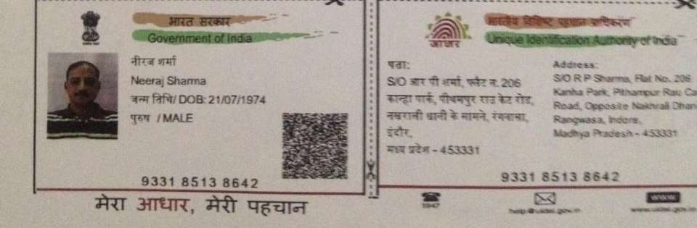

**Sambit Mishra:**

